CLPe Series
Manual Programming Cheat Sheet

- Turn the radio OFF
- Enter programming mode by doing the following (must have earpiece connected)
  - Press and hold the PTT, VOLUME +, and POWER buttons.
  - Keep all three buttons held down until you hear a chirping pattern with a “programming mode” voice prompt. The LED should be blinking GREEN or BLUE.
- Adjust your settings
  - Tap the MENU button once, and you will hear a channel number. Press VOLUME UP or VOLUME DOWN button to select your desired channel, once on your desired channel, proceed to below steps:
    - Tap the MENU button once, and you will hear a “Frequency” number. Change to the desired number by pressing the VOLUME UP or VOLUME DOWN button.
    - Tap the MENU button once, and you will a “Code” number. Change to the desired number by pressing the VOLUME UP or VOLUME DOWN button.
    - IF you need to change the settings on additional channels, tap the MENU button again until you hear the “Channel” number prompt and repeat the steps above. If you are finished, proceed to the next step to save your settings.
- Save settings and exit programming mode
  - To save settings and exit programming mode, press and hold the PTT button until the radio beeps. The LED will go back to the normal color according to radio channel (Red for Ch 1).
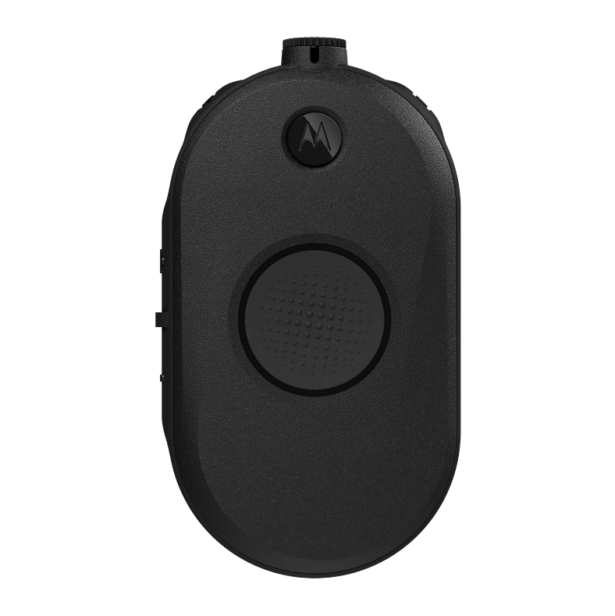

MENU
POWER
VOLUME UP / VOLUME DOWN

PTT

LED RING

